**EXISTING STUDENTS TABLE**  
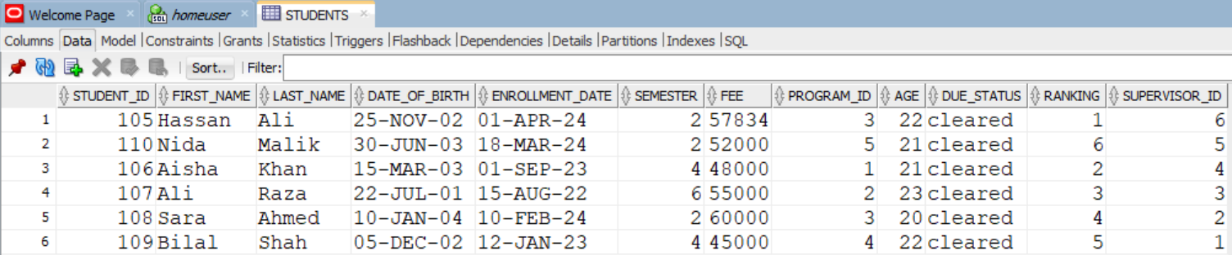

**EXISTING PROGRAMS TABLE  
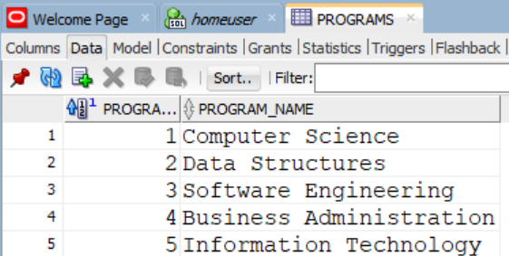**

**EXISTING FACULTY TABLE**

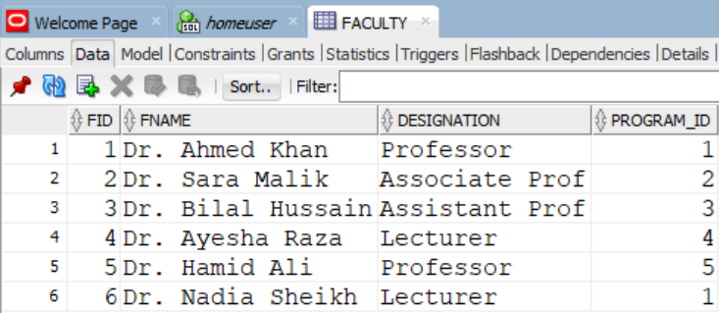

**LAB#04 – TASK#01**

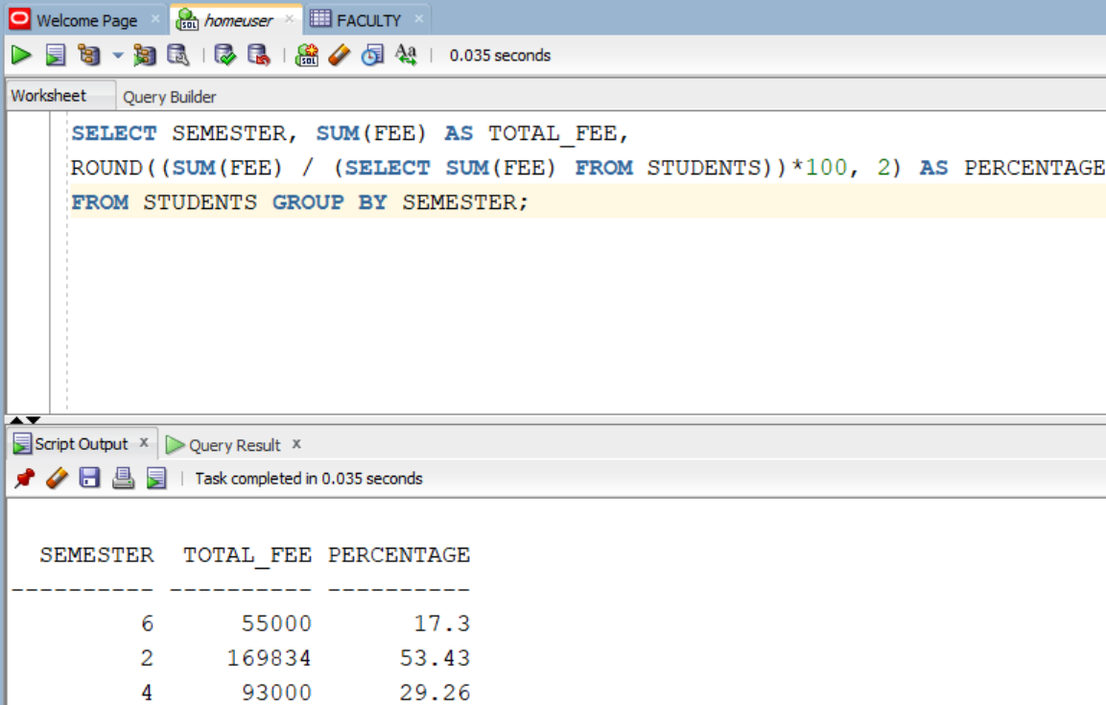

**LAB#04 – TASK#02**

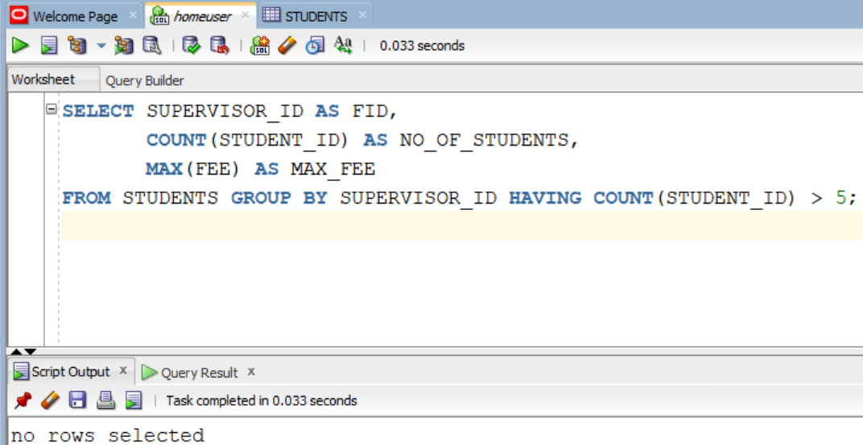

**Since not enough students in table**

**LAB#04 – TASK#03**

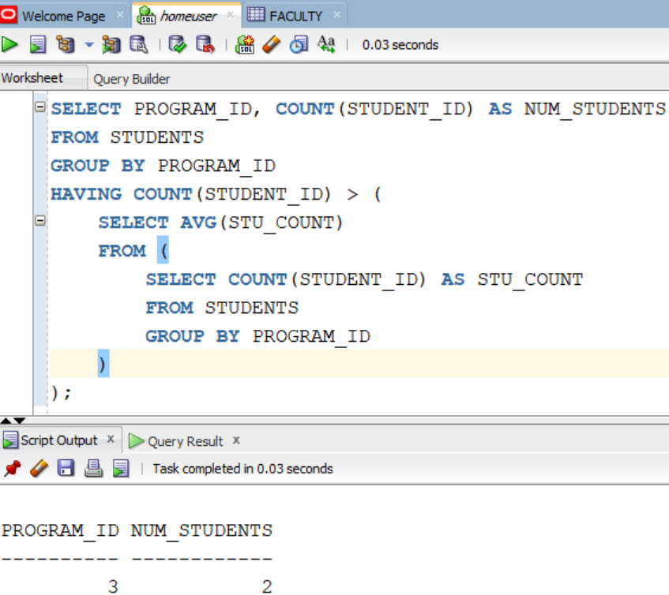

**LAB#04 – TASK#04**

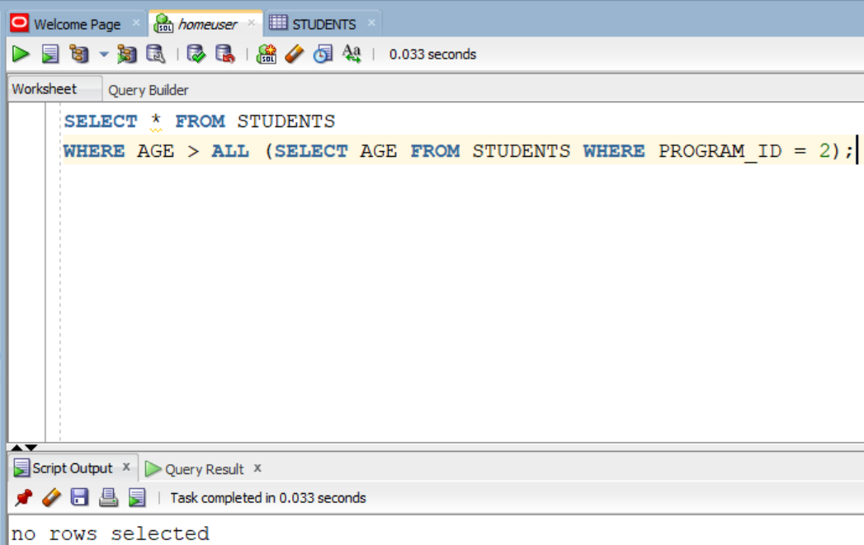

**Since no age > 23**

**LAB#04 – TASK#05**

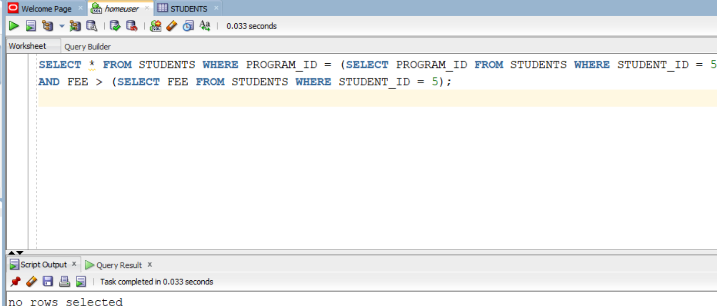

**Since not enough students in table**

**LAB#04 – TASK#06**

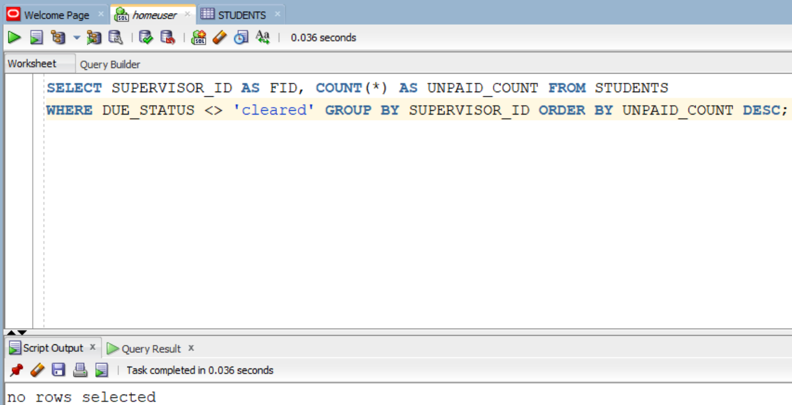

**LAB#04 – TASK#07**

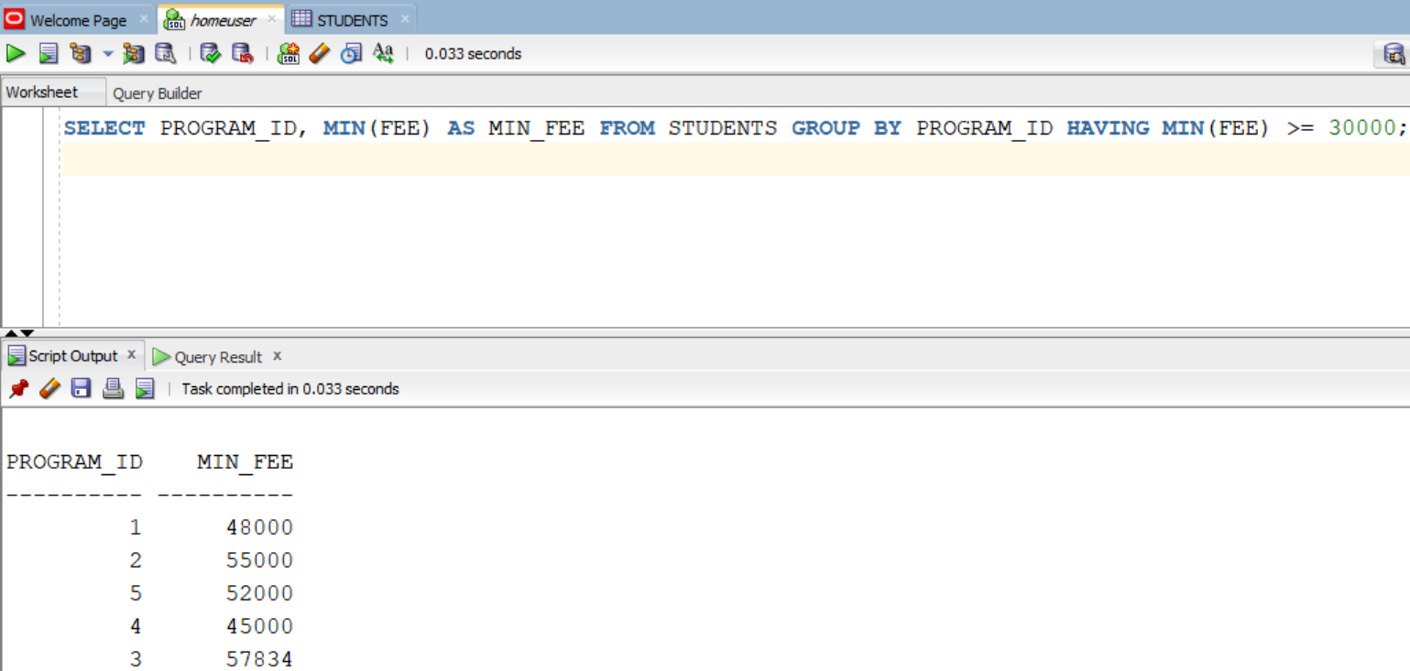

**LAB#04 – TASK#08**

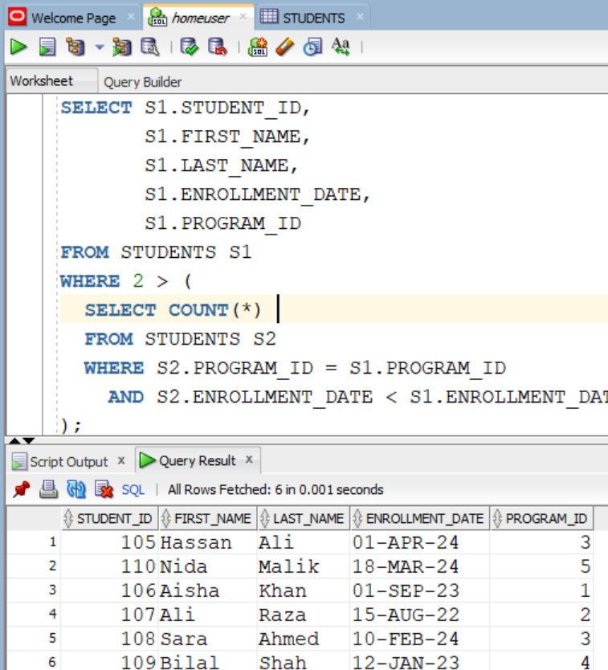

**LAB#04 – TASK#09**

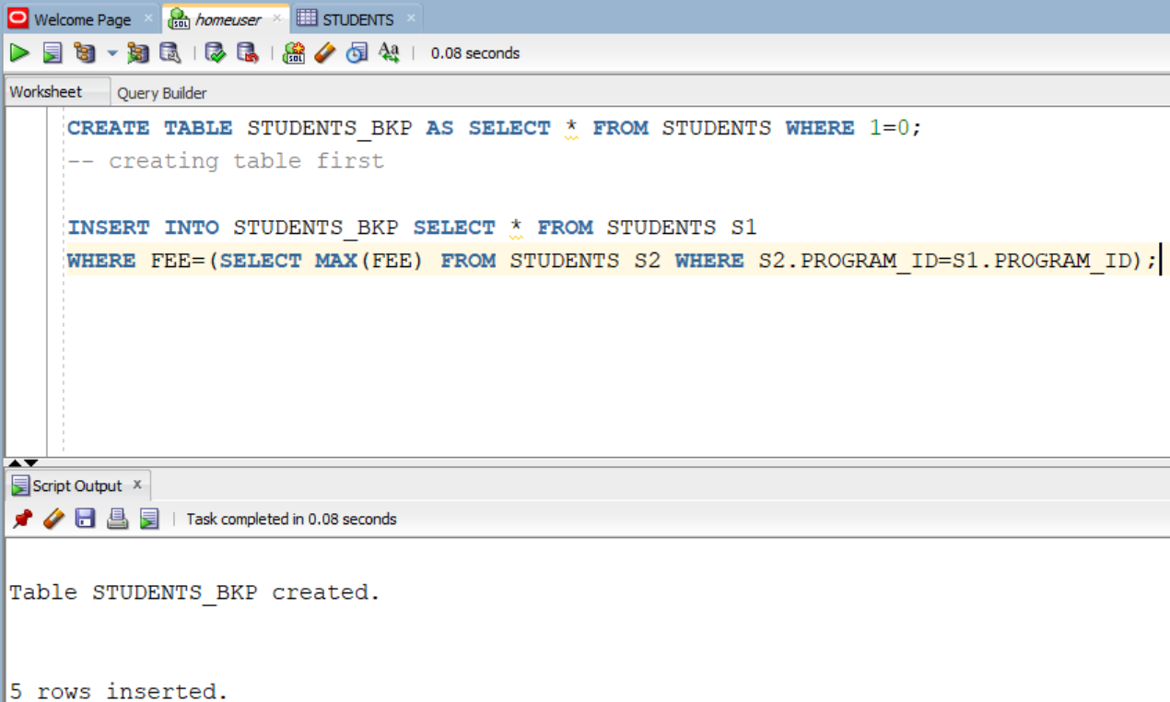

**LAB#04 – TASK#10**

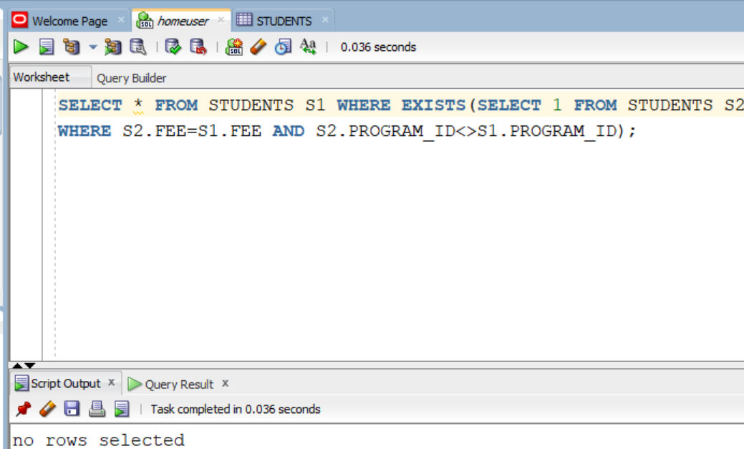

**Since not enough students in table**